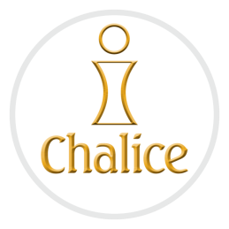
Cash & Cheque Donations Declaration Form
Chalice Champion’s Name: __________________
__Angelina D’Almeida ID 1224568___________
Phone: __(62506250_________________________________
Appeal: Plant Sale EV-

Scan & Email: donorrelations@chalice.ca; Fax: 1-902-252-3644; Mail Cheques & Money Orders only to: Chalice, 26 Union Street, Suite 1, Bedford, NS B4A 2B5

QUESTIONS? Call Ligia 1-800-776-6855 ext 208

PLEASE PRINT CLEARLY

Name* |  |  | Address* | Contact | Donation
First | Middle | Surname | Street, City, Province, Postal Code | Telephone, Email | Cash | Chq/MO
 |  |  |  |  | $ | $
 |  |  |  |  | $ | $
 |  |  |  |  | $ | $
 |  |  |  |  | $ | $
TOTALS |  |  |  |  | $ | $

*Required only if donor requests an official donation receipt.

Chalice Champion:

I, _______________________________________________declare that I have received cash and/or cheque donations from the above individuals.
These donations have been collected to support the work of: African School Farming and Food Project A-GTZ0321 ________________________

Signature: ____________________________________________ Date: __________________________________

(OFFICE USE) Acknowledged by: _____________________________________ Date Acknowledged: ______________________

