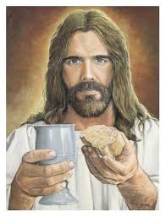
“Who is Jesus?”

Table of Beauty:
*** Need at least 1 Bible to use throughout both sessions ***
And an apple and small knife for cutting the apple

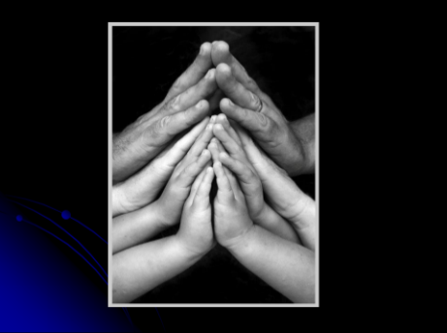
Opening Prayer:
In the name of the Father and of the Son, and the Holy Spirit. Amen
Come, Holy Spirit,
Fill the hearts of your faithful and kindle in them the fire of your love.
Send forth your Spirit and they shall be created
And you shall renew the face of the earth. Amen

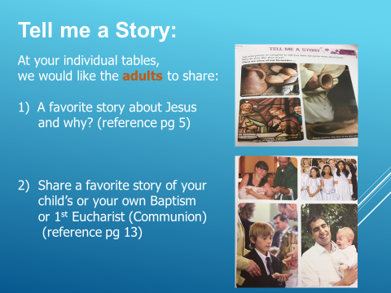
“Tell me a Story”
We would like the adults to share with students:
1) A favorite story about Jesus and why?
– take a few minutes to share
2) A favorite story of your child’s or your own Baptism
or 1st Eucharist (Communion
– take a few minutes to share
Thank you to everyone for sharing your stories

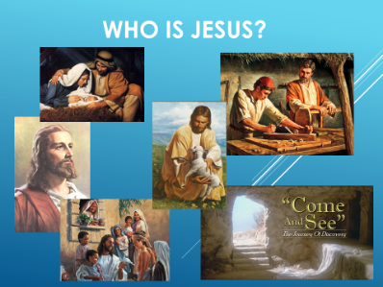
Who is Jesus?
It can sometimes be difficult to share things on the spot.
Many of you already know a number of stories from the Bible that are about Jesus. You have already discussed a few of those. During this time, we want you to get to know Jesus better and some of His teachings.
This will help you to grow and become a disciple of Jesus.

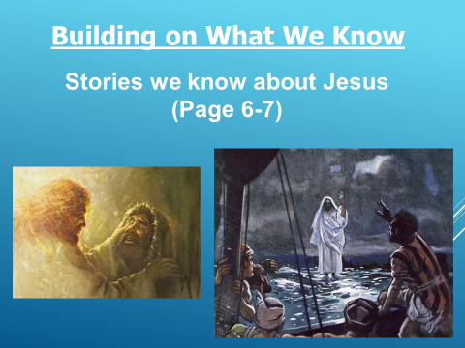
Building on What We Know:
There is an attached sheet that has stories from the Bible for reference to help with this task.
This is a time for students and adults to share a bit about the Bible and what they know. If you need help finding a Bible passage, just let us know and we can help.
Please see attached ideas as to where to find stories.
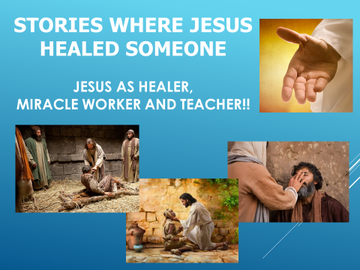
Please do not pick up your pens and pencils yet, we want to talk about this first. We want you to share stories that you already know about Jesus. Please do this together.
Stories Where Jesus Healed Someone:
Have a look at the pictures. This might help you to remember the stories. Ok, go ahead and share your answers.

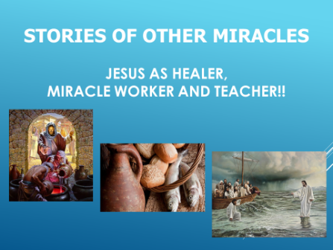
Stories of Other Miracles:
Again, Have a look at the pictures.
Ok, go ahead and share your answers.

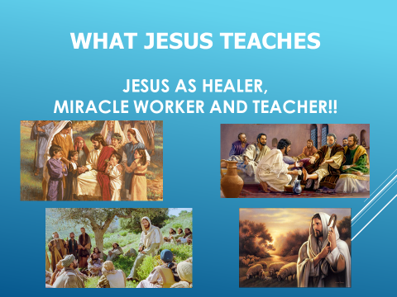
“What Jesus teaches”
Use the answers you have collected from the first 2 questions to be your guide. (ideas and thoughts attached above)
These answers are intended to be an exploration of what we learn from the stories that we have recalled.
Ok, go ahead and share your answers with each other again.

What have we discovered about the truths of Jesus:
- Jesus is there to save us all - Jesus is fully God - Jesus is full human
- Jesus is both human and God at the same time – part of the Mystery of the Trinity (3 in one)

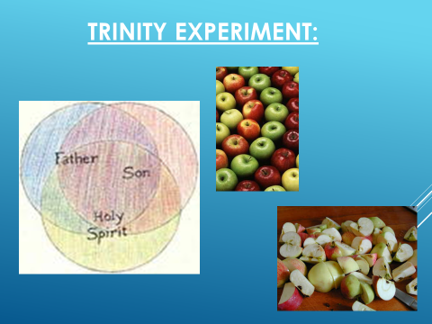
Trinity Experiment: apple
When we talk about the Trinity, we recognize that God comes in 3 forms.
He comes as God the Father, God the Son and God the Holy Spirit.
This is very similar to an apple. How is this possible?, you may ask.
So an apple is also made of 3 parts.
(use an actual apple to describe with a knife for cutting)

You see this apple – it has a peel. This peel protects that apple
(cut apple in half). Now that I have cut this apple in half you can see the flesh inside.
The flesh is the part we eat; the part that nourishes us.
Now let’s look at the seeds inside. The seeds are used to replant and create more apples.
We also know that even though this apple has 3 pieces it is still an apple.
It isn’t an orange or a banana or any other kind of fruit or vegetable. It is still an apple.

This is similar to God.
God the Father is like the apple peel – He protects us from harm
God the Son is like the flesh of the apple – we are nourished by Jesus at communion
God the Holy Spirit is like the seeds of the apple – seeds are planted in our hearts so that we may grow and feel God’s love in our lives and spread that love to others.

Just like the apple has 3 pieces, so does God have 3 pieces rolled into one God; the Trinity.

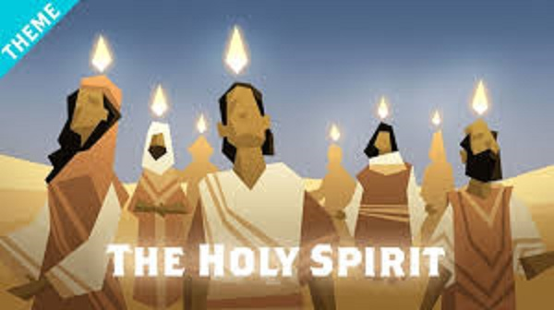
The Story of Pentecost:
Watch a video on the Holy Spirit.
In this video, they talk about how the Holy Spirit has been in our lives since the beginning of time.
At one point they will talk about how the Disciples are touched by the Holy Spirit and how we as disciples of Jesus also have an opportunity to be touched by the Holy Spirit.
** click on the youtube video and please watch the clip **
Teaching: - https://youtu.be/oNNZO9i1Gjc (The Holy Spirit Video – The Bible Project)

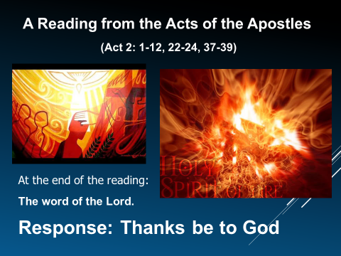
Now we are going to read the actual passage from the Bible that talks about Pentecost and what happened to the Disciples. Think about what is happening during this time in the Disciples life. We know that Jesus has died. We know that it must be during the Easter Season. We know that the Disciples of Jesus are probably very sad and confused because they don’t realize Jesus was going to die and now they are lost without their leader. Jesus has appeared to the Disciples but they still aren’t sure what they should do and how to move forward without Jesus.
Now it is the time of Pentecost when something very special happens.
We light this candle as a symbol of Jesus and His Light in our World. (light candle)
(please read directly from the Bible) Acts 2: 1-12, 22-24, 37-39
A reading from the Acts of the Apostles.
(at the end of the reading) – The Word of the Lord. Response: Thanks be to God

What part of the reading was the most important to you and why?
From the reading that we just read: “For the promise is for you, for your children, and for all who are far away, everyone whom the Lord our God calls to him (Act 2:39)
Do you hear that? It’s a PROMISE to you! The Holy Spirit’s gifts are promised to you.
In the Confirmation Session we will be exploring the 7 Gifts of the Holy Spirit and how to use them in our daily lives, just like the Disciples did all those years ago. By the way, we are all called to be Disciples of Jesus.

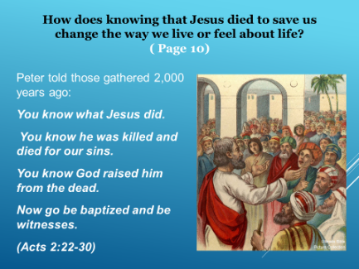
How does knowing that Jesus died to save us, change the way we live or feel about life?
Now turn to page 10 of your booklet. Under “Face2Face” it says from Acts 2, verse 22 to 39:
Peter told those people gathered 2,000 + years ago:
You know what Jesus did. You know he was killed and died for our sins.
You know God raised him from the dead. Now go be baptized and be witnesses.
My Thoughts Review
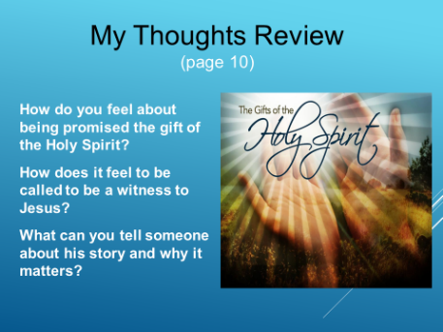
How does knowing that Jesus died to save us, change the way we live or feel about life? How do you feel about being promised the gift of the Holy Spirit?
How does it feel to be called to be a witness to Jesus?
What can you tell someone about His story and why it matters?

We will give you a few moments to think about these answers and please take the time to write your thoughts down
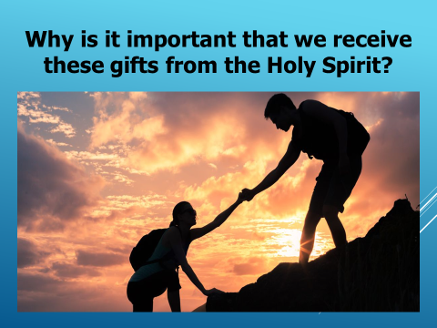
3) Why is it important that we receive these gifts from the Holy Spirit?
It is important because just like the disciples used their gifts to help people, you are also called to use the gifts you will be given and be disciples to help others and spread the Word of God.
This is why we are all called to help and be of service to others.

Jesus asks us to give of ourselves to others a minimum of 1 hr a week.
This is why we ask you to volunteer at least 1 hour a week for a min of 20 hours.

(break time or snack time if you like)

Baptism and Eucharist
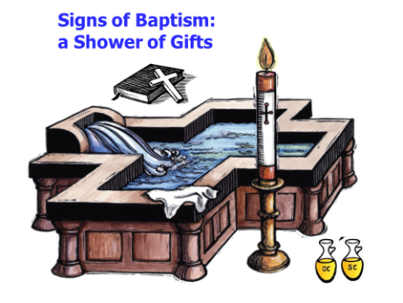
Baptism:
Baptism is a precious gift given by God through Christ.
We have the privilege of presenting your children or ourselves to receive this gift, a gift that will last a lifetime and beyond.
This gift is a Sacrament, an encounter with Christ himself.
Baptism is a moment when Christ comes to us and acts within us and among us.
In this encounter, we are transformed.
This is true for adults who understand the meaning of Sacrament and choose it for themselves,
And it is also true for babies and young children, at their Baptism.

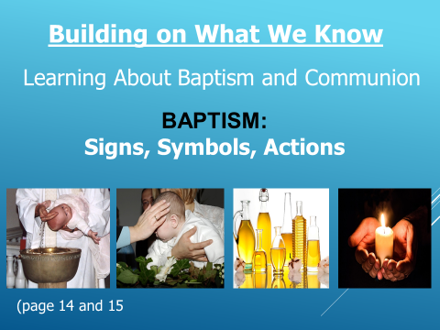
There are items on here specifically for Baptism.
Any ideas what they might be? (7 symbols)
- Water/bowl (washing/new life)
- candle (light of Christ)
- 2 holy oils (Chrism, Catechumen) - white garment (pure)
- cross (sign of the cross/blessing) - bible (word of God)

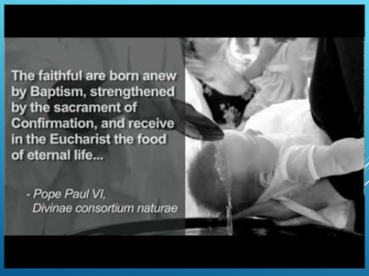
Please watch a short video on Baptism.
This will give you an idea about what it was like. See if you can recognize some or all the symbols that we just talked about.
Video: Busted Halo: Baptism
https://www.youtube.com/watch?v=05YB2jdHLsY

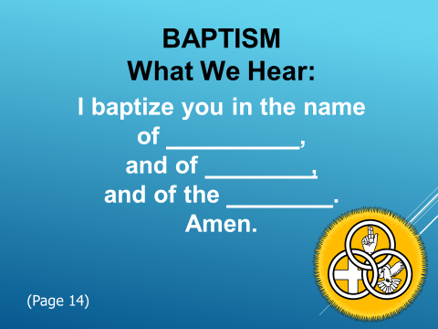
When a Priest Baptizes you these are the words he says: (Lets fill in the blanks)

“I Baptize you in the name of the Father,
and of the Son, and of the Holy Spirit”
Amen

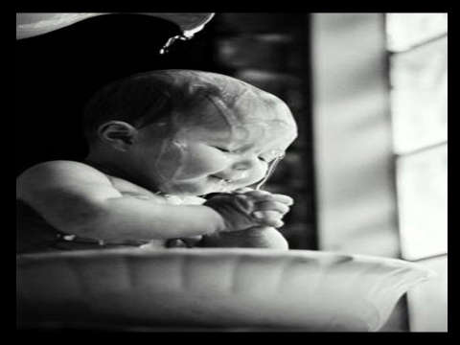
Your parents or you yourself are getting ready for the Sacrament of Baptism. You have a strong commitment to being raised in the Faith by receiving the Gift of Baptism.
You have carefully chose Godparents or Sponsors for you to help raise you in this Faith. When you are Baptized, you became members of the Church and the Body of Christ in Baptism.

The Baptismal Font is usually near the Altar to help us remember that every time we come to church “We are members of the Church and the Body of Christ”.

Profession of Faith:
For those who are already Baptize in a recognized Faith, they will make a Profession of Faith.
The priest will ask:
Candidate’s name of your own free, you have asked to be received
into the full communion of the Catholic Church.
You have made your decision after careful thought
under the guidance of the Holy Spirit.
I invite you to profess the Catholic faith
in the presence of this community.
In this faith you will be one with us for the first time
at the Eucharistic table of the Lord Jesus, the sign of the Church’s unity.
The candidates will echo the priest with the following words:
I believe and profess all that the holy Catholic Church believes, teaches, and proclaims to be revealed by God.

Then the priest with say:
The Lord receives you into the Catholic Church.
His loving kindness has led you here,
so that in the unity of the Holy Spirit
you may have full communion with us
in the faith that you have professed in the presence of his family.

After this there will be the Celebration of Confirmation and Eucharist.
Below is information on Eucharist and there is a separate Session on Confirmation.

Eucharist (Communion)

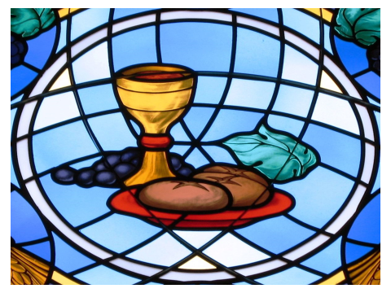
You will also have an opportunity to receive
When you received the Body and Blood of Christ for the first time it was recorded as a Special Occasion and this Gift is a Gift of the Sacrament of Holy Communion or Eucharist.

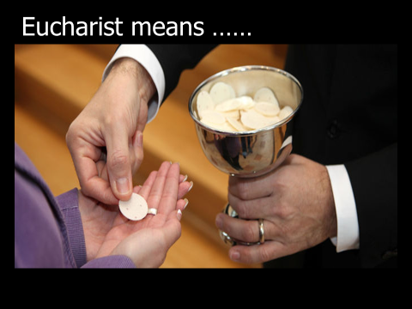
Notice that we are using the word Eucharist as well as Communion. Any idea why? (wait for answers).
The formal name for the Sacrament is Eucharist.
Eucharist comes from the Greek word meaning ??? “thanksgiving”.
So every Mass is a thanksgiving for Jesus’ saving sacrifice for us.
This is also called Communion or being in communion with Jesus and with each other.

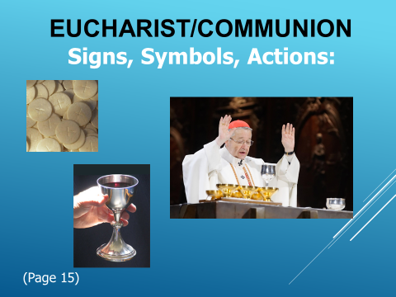
Have a look at the pictures and let us identify the Signs, Symbols and Actions for Eucharist or Communion:
Host – bread/ Jesus body Cup – wine/Jesus blood
What is the priest doing in this picture on the Power Point?
- Blessing the bread and wine – Its Greek name is epiclesis.

- e-pi-cle-sis – means covering of hands over the bread and wine before the Consecration
- The priest actually asks the Holy Spirit to come down and help him change the bread and the wine into the Body and Blood of Jesus Christ. So, did you think that the priest is somehow magical and the he could change the bread and wine himself? NO, the priest needs the help of the Holy Spirit, just like each of us do in our daily lives. God with of the help of the Holy Spirit helps us to do amazing things in our lives, if we only let Him.

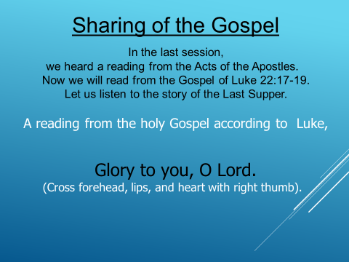
Sharing the Gospel: (read directly from the Bible)
In the last session we heard a reading from the Acts of the Apostles. Now we will read from the Gospel of Luke 22: Verse 17-19.
Let us listen to the story of the Last Supper.
Now because this is a Gospel reading we ask you to stand, just like we do at church. (all stand)
A reading from the Holy Gospel according to Luke,
Glory to you, O Lord
(make the sign of the cross your forehead, lips, and heart with your right thumb)
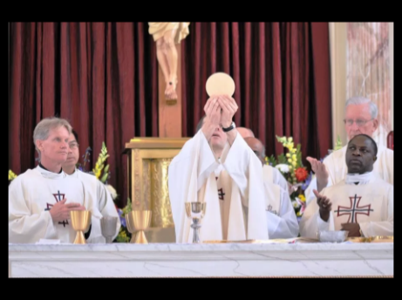
From this reading we hear Jesus talking about sharing of the bread and wine with the community.
At Mass, the priest will say similar words to share the bread and wine, the Body and Blood of Jesus, with the community, as well as remind us that
Jesus sacrificed himself for all of us.

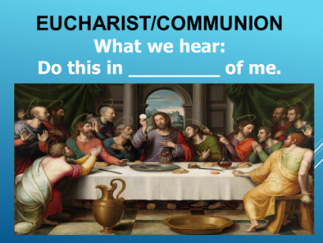
During the Consecration at Mass (Consecration means: the action of declaring and changing bread and wine to the body and blood of Christ),
the priest will say these words that Jesus said: (look on page 15 and fill in the blank)
What we hear:
Jesus says: “Do this in memory of me.”

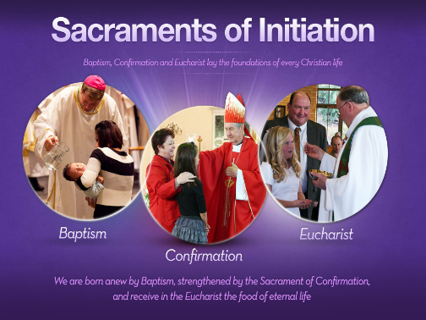
Our Response to God’s Grace:
The 3 main Sacraments Are Baptism, Confirmation and Eucharist.
These are called Sacraments of Initiation
We are born anew by Baptism, strengthened by the Sacrament of Confirmation,
and receive in the Eucharist the food of eternal life.

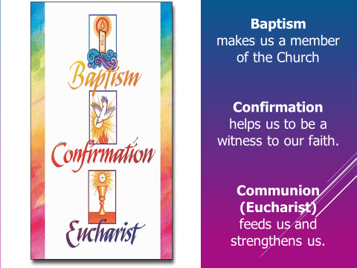
Baptism: is a Gift from God so that we can formally become members of the Church
Confirmation helps us to be a witness to our faith and helps guide us on our journey of Faith.
Communion/Eucharist feeds us and strengthens us with the Body of Christ.

What does Baptism or Profession of Faith mean to you?
What does Eucharist or Communion mean to you?

In this video below there is a young man and a young lady who are trying to meet with each other.
One of them gets very lost and has to “listen to the GPS” and re-navigate.

Often times when we are on a Journey ourselves and sometimes we need someone or something to help us re-navigate so that we are headed in the right direction. We are never alone!

Navigation Video: Confirmation by Matthew Kelly https://www.youtube.com/watch?v=axliNB8f4KQ
Just like the young people in this video, we are also on a Journey ourselves and sometimes we need someone or something to help us
re navigate so that we are headed in the right direction.
God, our family, people around us can help us to re-navigate.
The Sacraments also help us to re-navigate and head back to our Faith and to the church.

At Baptism you will make a series of promises.
This is why it is so important that you have a Sponsor.
One of these promises is to help each other to be “Trained in the Faith” over your whole life.

Training in faith is just like training in sports or music or anything we need to train at so that we know what we are doing.
It’s not about being perfect; it’s about learning and trying and practicing so you can do better.
Everyone who trains should have a coach.
Well, your family, your school, everyone at your parish can help with this training in the faith!
We can be your coach. These are training sessions to help us better understand our faith.

Think about what 2 ways that you can work on what Baptism calls “training in the faith”.

How does knowing that Jesus died to save us change the way you live or feel about life?
Think of two ways you can work on what Baptism calls “training in the faith.”

Pope Francis says, “The internet, in particular, offers immense possibilities for encounter and solidarity. This is something truly good, a gift from God.”(Message for the 48th World Communications Day June 1, 2014 – www.new.va

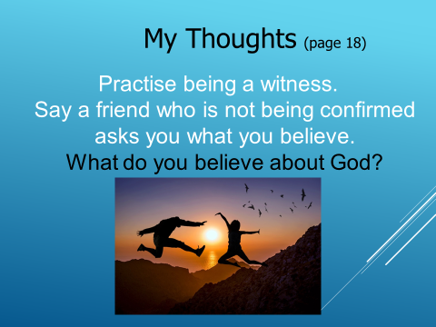
My Thoughts:
Practice being a witness.
Say a friend who is not being confirmed asks you what you believe.
Please think about these next 3 questions and write your own private answers.
What do you believe about God?

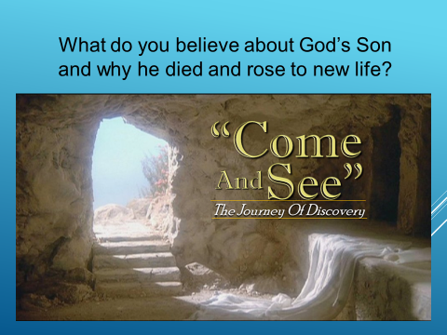
What do you believe about God’s Son
and why he died and rose to new life?

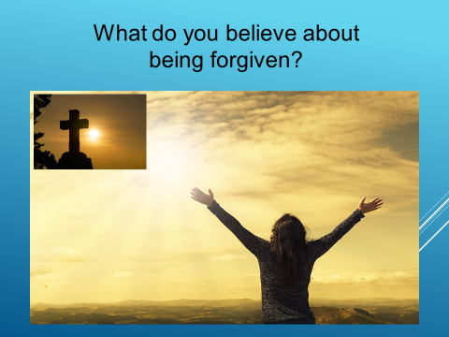

What do you believe about being forgiven?

Before we have our Closing Prayer we have a few thoughts for you!
Evangelizing Thoughts:
I believe in God. I believe that God’s grace comes to us in a special way through the Sacraments and knowing Jesus. I know that God’s grace is at work in all of our lives!

You all have an opportunity, with God’s help, to be what you want to be.
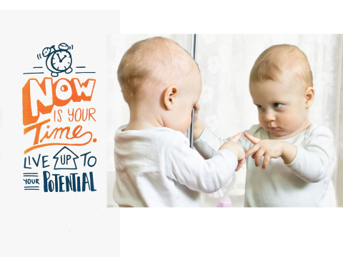
Now is Your Time. Live up to your Potential.

Go for it! You Can Do It!

Any questions or concerns please contact:
St Mary’s: Charmaine at charmaine.marcinek@caedm.ca or 403-347-3114
The Prayer is called the Dynamic Catholic Prayer:
