Confirmation Session
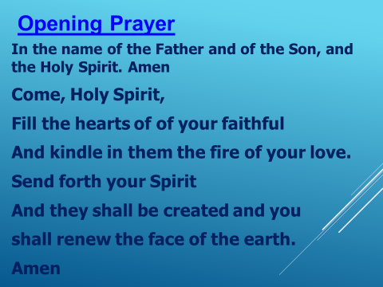

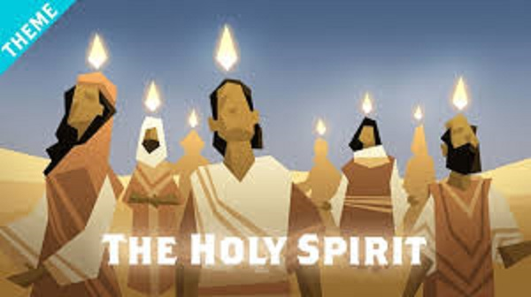
The Story of Pentecost: - we are going to watch a video on the Holy Spirit.
In this video, they talk about how the Holy Spirit has been in our lives since the beginning of time.
At one point they will talk about how the Disciples are touched by the Holy Spirit and how we as disciples of Jesus also have an opportunity to be touched by the Holy Spirit.
** click on the youtube video and please watch the clip **
Teaching: - https://youtu.be/oNNZO9i1Gjc (The Holy Spirit Video – The Bible Project)

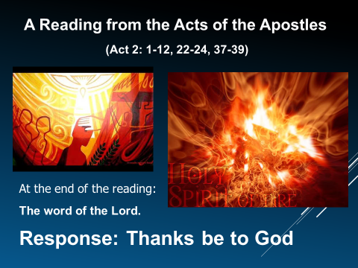
We are going to read the actual passage from the Bible that talks about Pentecost and what happened to the Disciples. Think about what is happening during this time in the Disciples life. We know that Jesus has died. We know that it must be during the Easter Season. We know that the Disciples of Jesus are probably very sad and confused because they don’t realize Jesus was going to die and now they are lost without their leader. Jesus has appeared to the Disciples but they still aren’t sure what they should do and how to move forward without Jesus.
Now it is the time of Pentecost when something very special happens.
We light this candle as a symbol of Jesus and His Light in our World. (light candle)
(please read directly from the Bible) Acts 2: 1-12, 22-24, 37-39
A reading from the Acts of the Apostles.
(at the end of the reading) – The Word of the Lord. Response: Thanks be to God

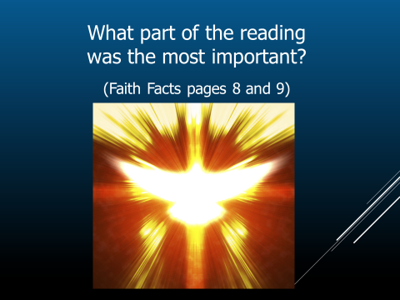
1) What part of the reading was the most important?
The Holy Spirit comes to the disciples and brings them gifts.
7 Gifts of the Holy Spirit:
Wisdom, Understanding, Right Judgement, Courage, Knowledge, Reverence, Wonder and Awe in God’s Presence
We will talk more about the the 7 Gifts a bit later.
From the reading that we just read: “For the promise is for you, for your children, and for all who are far away, everyone whom the Lord our God calls to him (Act 2:39)
Do you hear that? It’s a PROMISE to you! The Holy Spirit’s gifts are promised to you.
In your “Catholic Parent Know How” booklet it talks about the “Gifts of the Holy Spirit”.
Exploring these 7 gifts and how to use them in our daily lives, just like the Disciples did all those years ago. By the way, we are all called to be Disciples of Jesus.

Why is this reading important for people who are thinking about Confirmation? Any idea?
(invite a few answers)
It tells us about the Holy Spirit coming to the first Disciples. The Holy Spirit will come to you as candidates in Confirmation. Will it be as dramatic as the Disciples? Probably not. It does remind us that we are called to be baptized and to be witnesses to Jesus. We really hear that the Holy Spirit is promised to us.

What does the word RUAH stands for. Any idea? Think about the Holy Spirit coming down to the apostles. What did the video tell us it was?
The “Holy Spirit filled them with fire and …….” - wind or breath of God.
When we say RUAH it is like a breath. RU – HAH! (make a breathy sound)
It reminds us that we are called to be baptized and to be witnesses to Jesus. We hear the Holy Spirit promised to us.
- What are the 2 symbols of the Holy Spirit? Fire and Wind (RUAH)
- How do the disciples know what Jesus did and how were they able to tell all those stories? The disciples followed Jesus and were witnesses
- What is the first step to take to be a disciple? Be baptized.

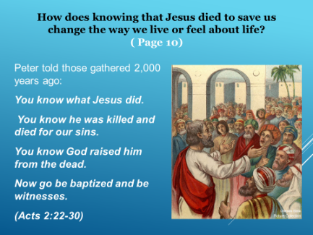
How does knowing that Jesus died to save us, change the way we live or feel about life?
Peter told those people gathered 2,000 + years ago:
You know what Jesus did. You know he was killed and died for our sins.
You know God raised him from the dead. Now go be baptized and be witnesses.

My Thoughts Review
How does knowing that Jesus died to save us, change the way we live or feel about life?
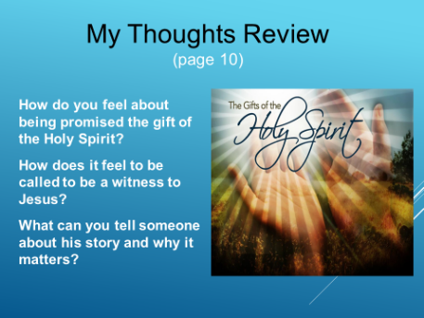
How do you feel about being promised the gift of the Holy Spirit?
How does it feel to be called to be a witness to Jesus?
What can you tell someone about His story and why it matters?

We will give you a few moments to think about these answers and please take the time to write your thoughts down. (2 or 3 min)
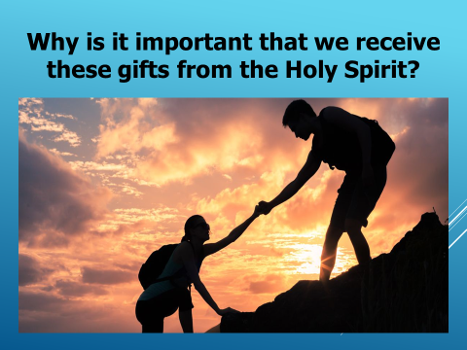
3) Why is it important that we receive these gifts from the Holy Spirit?
It is important because just like the disciples used their gifts to help people, you are also called to use the gifts you will be given and be disciples to help others and spread the Word of God.
This is why we are all called to help and be of service to others.
Jesus asks us to give of ourselves to others a minimum of 1 hr a week.
This is why we ask you to volunteer at least 1 hour a week for a minimum of 20 hours.
Please check your Volunteer Sheet and work on those hours.

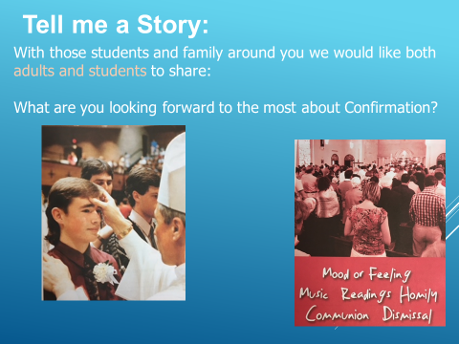
“Tell me a Story”
What are you looking forward to the most
about Confirmation?

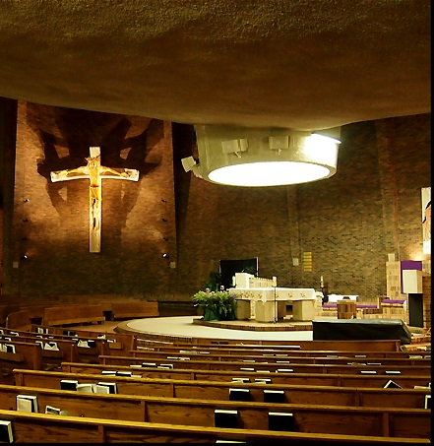
Building on What We Know:
Everyone appreciates a celebration that feels like a Celebration. We take time to have careful and clear readings so that we can appreciate them. The music ministry prepares music that will help you connect to the Celebration. There are ministries behind the scenes that are helping to make sure everything runs smoothly. Preparing in advance improves the experience on the day.
This is why it is so important to be present for the Rehearsal.
We are going to practice some of this today.

The Teaching: - Some Responses to Practice
Throughout Mass the Priest will say:
The Lord be with you. And you will respond: And with your Spirit
Whenever you hear this:
“Through Christ our Lord … “it’s a clue that it’s the end of a prayer.
The response is – Amen

The Priest with say, ‘May almighty God bless you, the Father, and the Son, and the Holy Spirit.” Making the sign of the cross with his hand. The response is to make the sign of the cross on yourself as usual and respond - Amen .
By the way, what does Amen mean? Yes, I believe!

Remember that during the Homily, the priest might be speaking to you directly.
Stay calm, respond clearly, Enjoy! The message is for you to hear.
The Rite of Confirmation: We have heard God’s word
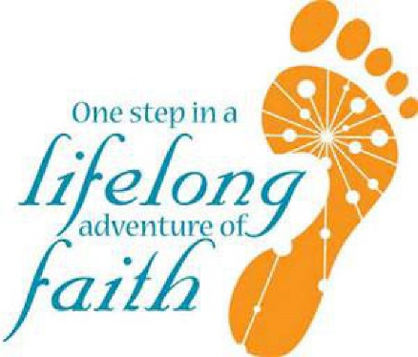
After the Homily the Rite of Initiation begin.
3 important and ancient rites now take place.
1) Baptism or Renewal of Baptismal Promises (Profession of Faith)
2) Laying on of Hands
3) Anointing with Chrism
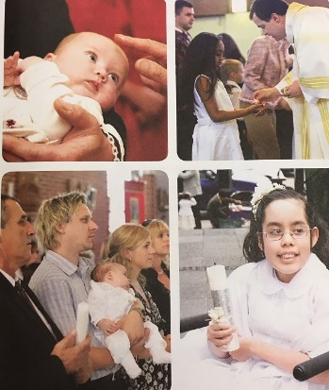
1) Renewal of Baptismal Promises: - Response: I do
Do you believe in God, the Father almighty, creator of Heaven
and earth? I do
Do you believe … etc. I do.

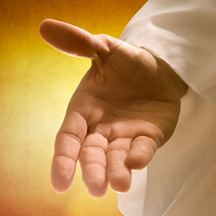
2) Laying on of Hands:

Priest give a blessing by laying their hands on a person’s head or by extending their hands over the person or group of people.
This happens at Baptism, at Confirmation, the Anointing of the Sick, and at Ordination. This action is accompanied by a prayer to the Holy Spirit, which calls the Spirit upon each of you.

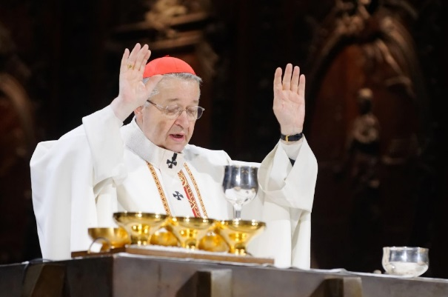
During Mass, the Priest puts his hands over the bread and wine and calls upon the Holy Spirit to forever change the bread and the wine to the Body and Blood of Christ. (epiclesis)

In Confirmation, the Archbishop or Priest will place his hands over you and call upon the Holy Spirit, and you will be changed. You receive the power and the gifts of the Holy Spirit to bear witness to Jesus Christ.

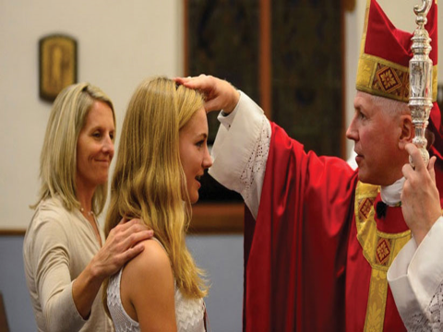
3) Anointing with Chrism – please practice this at home
A deacon or minister brings the Chrism to the Archbishop or priest.
Each candidate, with his or her sponsor walks up to the Archbishop or priest. The Archbishop or priest will be standing near the bottom of the stairs to greet you individually.
The sponsor places their hand on the shoulder of the candidate. This is to Symbolize that your Sponsor ‘has your back’ and with be there for you just like the entire Catholic community is there for you.
The Sponsor needs to have the name card of the Candidate with them.
Name cards will be on the table in the hall on Confirmation day, along with your child’s Certificate and sign in sheet.
The Sponsor will hold the name card up for the Archbishop to see, as well as say the first name of their Confirmandi to the Archbishop or priest.
We will alternate rows with one candidate in front of the Archbishop or priest and the rest of that individual pew waiting in the aisle.
Stand close, and please make your responses are loud and clear (no mumbling please)
* no pictures are to be taken within the Mass – please let all family know

Archbishop or the priest dips his right thumb in the Chrism and makes the sign of the cross
on the forehead of the one to be confirmed as he says:

Archbishop/Priest: (Name of candidate), be sealed with the Gift of the Holy Spirit.
Response: Amen.
Archbishop/Priest: Peace be with you. Response: And with your spirit.

After you are Confirmed, please return to your pew with your Sponsor.
Please take this time back in your pews to reflect on this Sacrament of Confirmation and the Gifts of the Holy Spirit that you have been given. This is not a time for talking to your neighbor. You can also join in singing with the Music Ministry.
After everyone has received the Sacrament of Confirmation,
Then Mass will continue as usual with the Prayers of the Faithful.

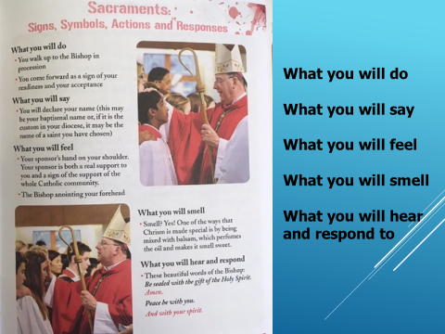
Sacraments: Signs, Symbols, Actions, and Responses –
What you will do, say, feel smell hear and respond.
These are all parts of the Sacrament of Confirmation and what we just practiced.
Take time to review

Remember that Sacraments are guaranteed to “work”!
It’s not as though we all hope to receive God’s grace. We DO receive God’s grace.
Sacraments are NOT magic. We receive God’s grace and then we have to choose to co-operate with that grace.
How we act and react to the Sacrament is what counts. This means our openness and preparation is important in ensuring an attitude that allows us to co-operate with God’s grace.
Cooperating with God’s grace means learning more and more about what God wants for us and how we go about doing and acting the way in which He wants.

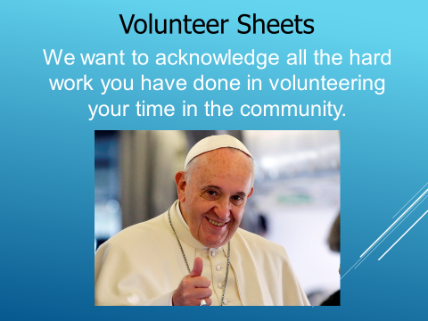
Volunteer Sheets: We want to acknowledge all the hard work you have done in volunteering your time here in the community.
Was the 20 hours easy or difficult to complete?
Please keep the sheets that you have completed.
We do not need a copy.

Gifts of the Holy Spirit
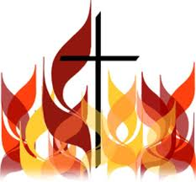
Prayer:
O Lord Jesus Christ, before ascending into heaven,
you promised to send the Holy Spirit to finish your work
in the souls of your apostles and disciples.
Grant that we may be open to the work of that same Spirit within us, that he may perfect in our souls the work of your grace and your love. Amen

Exploring the Gifts of the Holy Spirit: read Romans 12: 3-8
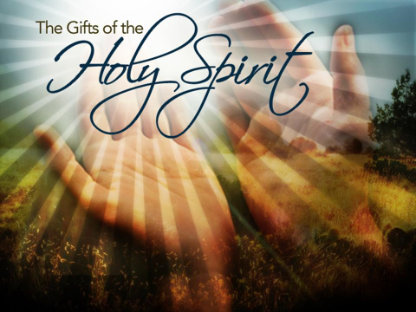
They talk about the Gifts of the Holy Spirit.
On page 44 of your booklet talks about the 7 Gifts of the Holy Spirit.
Choose from the list below the names of those gifts.
Write them on the lines provided. Be careful!
There are some words here that don’t belong!

7 Gifts: wisdom, understanding, knowledge, wonder and awe, reverence, right judgement, and courage

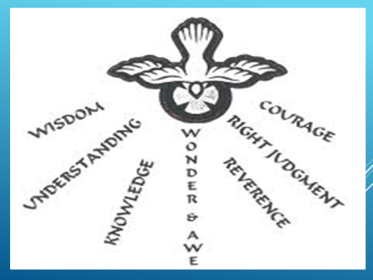
Have a look at all 7 gifts below and discuss what gifts you think you already have. What gifts do you need to work on?
Share with those around you.
Talk about what Gifts others think you might have and why.

WISDOM: Grant us the Spirit of Wisdom that we may grow in understanding of your love and compassion for us. Help us to love you with all our heart.

UNDERSTANDING: Grant us the Spirit of Understanding to enlighten our minds with the light of your truth. Help us to learn about our one true faith in you.

KNOWLEDGE: Grant us the Spirit of Knowledge that we may know God and know ourselves. Help us to see ourselves and others as images of God.

WONDER AND AWE: Grant us the Spirit of Wonder and Awe, that we come to an awareness that God alone deserves our trust and our respect. This world has wondrous things for us to explore and understand. God open our eyes to the wonders around us.

REVERENCE: Grant us the Spirit of Reverence that we may be loyal and faithful to those around us and find the service of God to be kind and worthy. Help us to honour and respect God, and all people as children and images of God.

RIGHT JUDGEMENT: Grant us the Spirit of Right Judgement that we may always choose the surest way of pleasing God and gaining our place in Heaven. Help us to make good decisions.

COURAGE: Grant us the Spirit of Courage that we may bear our cross with you and that we may overcome all obstacles without giving up hope. Help us to love God and others, especially when it is difficult.

My Prayer to the Holy Spirit

We began each of our sessions with a prayer to the Holy Spirit.
As you continue your journey to Confirmation, remember that the Holy Spirit is always guiding you along the way.
Let’s center ourselves for prayer.

Prayer:
Dear God, we thank you for the many gifts you have given us.
We know that all our blessings come from you.
Help each of us take time to recognize our gifts,
and work toward developing these gifts.
May we be willing to reach out to others
and share all that we have been blessed with.
For it is in helping others that we gain joy and fulfillment here on Earth.
Lord, help us see today the wonderful gifts with which we have been blessed.
Help us discover the hidden talents and skills we possess.
May we recognize our potential and never underestimate all we can achieve.
We ask this through Jesus, Our Lord and Savior. Amen.

You have all worked hard to journey to this point.
Congratulate yourselves and thank the people who have been part of your journey.
Thank you and see you all when we have an opportunity to receive the Sacraments.

