The Way of the Cross for Children
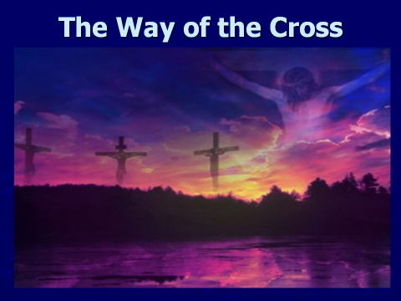
Opening Prayer: (say together as family)
O great and loving God,
Prepare our hearts now to walk with Jesus on the Way of the Cross.
Help us to open our minds and hearts to allow Jesus to speak to us and teach us.
Thank you for this opportunity we have to gather in Your love.
This we ask through Christ our Lord,
Amen.

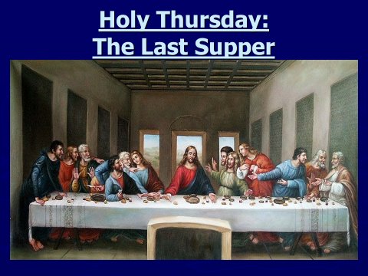
Holy Thursday/The Last Supper
Jesus said to them, “I have wanted so much
to eat this Passover meal with you!
For I tell you, I will never eat until it is given its full meaning in the Kingdom of God.”

Then Jesus took a cup, gave thanks to God, and said, “Take this and share it among yourselves.
I tell you that from now on I will not drink this wine until the Kingdom of God comes.”

Then he look a loaf of bread gave thanks to God broke it and gave it to them saying, “This is my body, which is given for you. Do this in memory of me.” In the same way, he gave them the cup after supper, saying. “This cup is God’s new covenant sealed with my blood, which is poured out for you.”

Pray together: (say aloud)
Jesus, we know You love us.
We hope to receive the Eucharist often and be nourished by Your love for us.

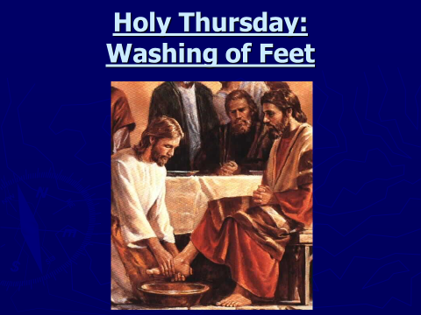
The Washing of the Feet:
Before they ate the bread and the wine at the meal, Jesus washed the feet of the disciples.
They were very surprised, because usually servants washed the feet of the people entering the house. Peter, said that he didn’t want Jesus, the Messiah, to wash his feet, but Jesus said that he might not understand it at the moment, but unless you let me wash your feet, you cannot truly belong to me. Peter then replied, please Master, wash my feet and wash all of me.
Jesus, replied that he didn’t need to wash all of Peter because he was clean. Jesus went on to say that not all the disciples present were clean. Jesus was talking about Judas who was soon to betray Him.

Pray together: (say aloud)
Jesus, we know You love us.
We hope to serve you and follow you.
Help us to remember to be there to help others in need
and be a service to our community.

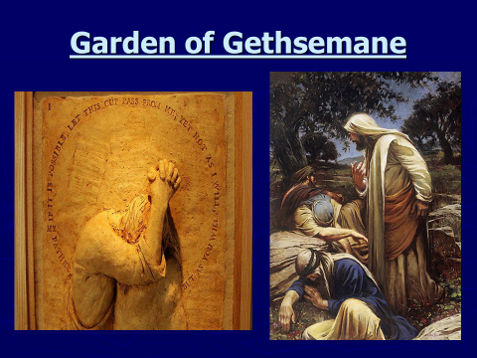
In the Garden of Gethsemane (Matthew 26: 36-41)
Then Jesus went with his disciples to a place called Gethsemane, and said to them, “Sit here while I go over there and pray.” He took with him Peter and the two sons of Zebedee. Grief and anguish came over him and he said to them. “The sorrow in my heart is so great that it almost crushes me.” Stay here and keep watch with me.
The disciples tried, but they fell asleep, they couldn’t stay awake even though Jesus really needed them. Jesus was very disappointed.

Pray together: (say aloud)
Jesus, we know You love us.
Comfort us in times of sadness, uncertainty or difficulty.
Sometimes we find we are ignored, lonely and abandoned at our time of need.
Help us to remember that we are not alone. Jesus, You are always with us and will be there in friendship and love to give us peace, strength and comfort.

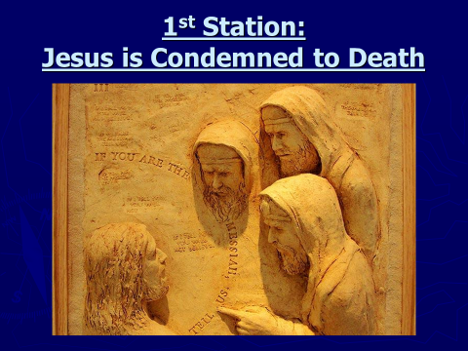
1st Station: Jesus is Condemned to Death:
Jesus was taken to the High Priest’s house, where the chief priests, the elders and the teachers of the Law were gathering. Peter followed at a distance and went into the courtyard, where he sat down with the guards, keeping himself warm by the fire. The chief priests and the whole Council tried to find some evidence against Jesus in order to put him to death, but they could not find any.

Pray together: (say aloud)
Jesus, we know You love us. Help us to forgive those who might say mean or hurtful things about us or lie about us. Help us to be more loving like You.
We know that God is always with us no matter what.

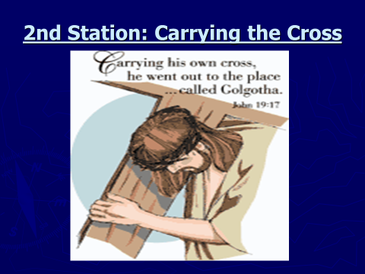
2nd Station:
Carrying the Cross (John 19:6, 15-17)
Pilate took Jesus and had him whipped. The soldiers made a crown of thorny branches, put it on his head, then put a purple robe on him. They came to him and said, “Long live the King of the Jews!” and slapped him.
The soldiers took charge of Jesus. He went out, carrying his cross and came to the ‘Place of the Skull,’ as it is called. (In Hebrew it is called ‘Golgotha’)
Pray together: (say aloud)
Jesus, we know You love us. Help us to understand when things are hard for us.
Jesus, help us to remember that God is always there to help carry the load.

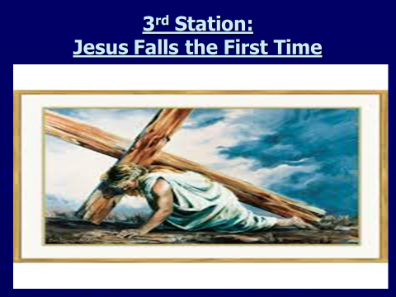
3rd Station: Jesus Falls for the First Time
I must get up! Jesus falls under the weight of the cross. He is determined to fulfill the mission of God, his Father, has entrusted to him. There are people all around watching and wanting to help him but are afraid. Jesus knows he must go on – the people watching do not offer any support; they cannot help or they really don’t want to help or get involved.

Pray together: (say aloud)
Jesus, You love us.
Please forgive us for the times we have walked away from the burdens of others.
Help us to listen and be understanding towards others. Teach us how to follow You.

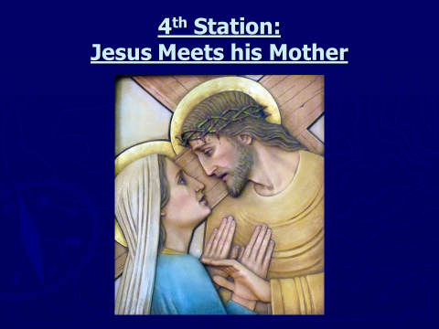
4th Station: Jesus Meets His Mother
“Mother” – “Son” – Mary shares is her Son’s suffering. The crown of thorns that adorns Jesus’ head is extended to His mother’s head. Mary places her hand upon the heart of her Son, Jesus, and her shoulder under His cross. Mary loves her son so much that she is willing to die for her beloved Son and take his pain and suffering.

Pray together: (say aloud)
Jesus, You love us. You gave us Your mother Mary as our own Mother.
Help us to remember to ask Mary for her nurturing love, compassion and understanding when we or others around us are in need.
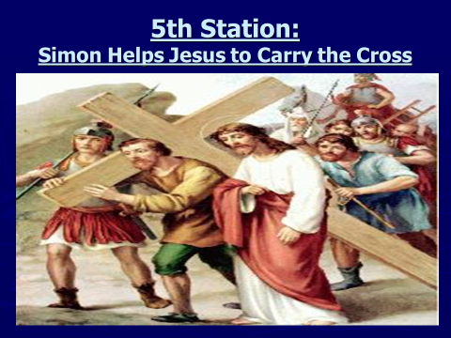
5th Station: Simon of Cyrene:
Simon Helps Jesus Carry the Cross
On the way they met a man named Simon, who was coming into the city from the country.
Simon helps Jesus by carrying the heavy cross. He is not concerned that he might be punished. Simon knows that this is the right thing to do.

Pray together: (say aloud)
Jesus, we know You love us.
Jesus, forgive us for the times we have walked away from others who could use our help. Help us to be kind and helpful towards others in need.
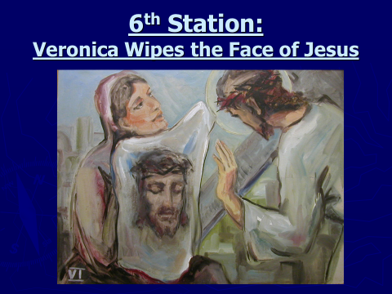
6th Station: Veronica Wipes the Face of Jesus
Veronica is moved with compassion and wipes Jesus sweat and blood off his face. The image of his face remains preserved on the cloth.
She knows in her heart it is the right thing to do.

Pray together: (say aloud)
Jesus, You love us.
Help us to show compassion and generosity towards others.
Teach us to do what is right regardless of the consequences.
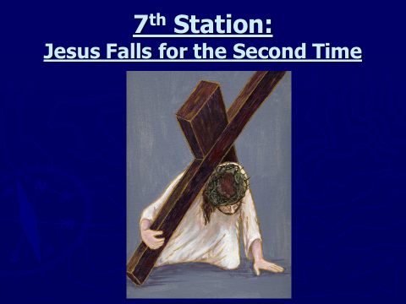
7th Station: Jesus Falls for the Second Time
I must continue! Jesus falls more heavily; it is harder for him to get up. Jesus seems to reach out to someone.
It is a sign that the love that Jesus have for his people compels him not to quit.
He must continue.
He must do what he has been asked to do.

Pray together: (say aloud)
Jesus, we know You love us.
Help us to have the strength to stand up for what we believe and know what is right.
Protect us from being bullied by what others say or do.
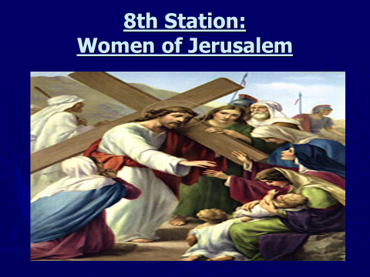
8th Station: The Women of Jerusalem
A large crowd of people followed Jesus and the cross as he travelled; among them were some women who were weeping and crying for him.
Jesus consoles the women.

Pray together: (say aloud)
Jesus, we know You love us.
Help us to remember the times when we have helped someone in need; a smile, or helping around the house. Help us continue to do these things with a generous heart.
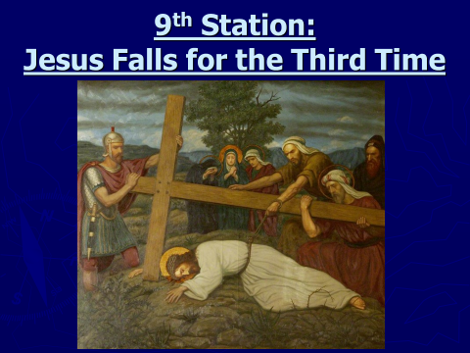
9th Station: Jesus Falls for the Third Time
I must finish! Jesus is at the end of his strength; but he has to finish what he started.
Jesus started with friendship and love and he will not quit now.

Pray together: (say aloud)
Jesus, we know You love us.
Comfort us in times when we fall.
Help us to see past the hurt and to the hope of truly believing.
Help us to remember that You are always with us and will be there in friendship and love.
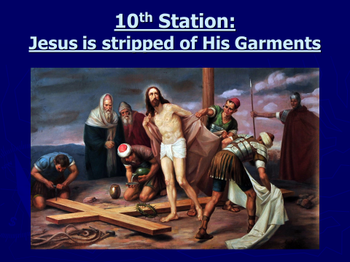
10th Station: Jesus is stripped of His Garments
They came to a place called Golgotha, which means ‘Place of the Skull’. There they offered Jesus wine mixed with a bitter substance; but after tasting it, he would not drink it.
Jesus is stripped of his clothes and the soldiers gamble for his seamless robe. (casting lots). Jesus is stripped and robbed of absolutely everything.

Pray together: (say aloud)
Jesus, You love us.
You have given everything You have for us.
Show us how to be there for others and give all that we have.
God is always with us, we are never alone.

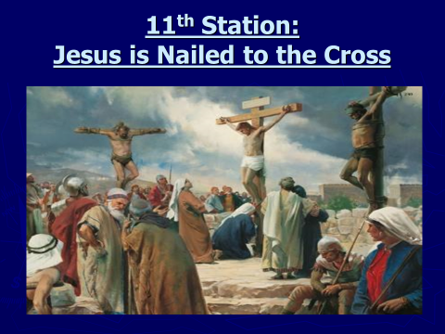
11th Station: Jesus is Nailed to the Cross
Crucified for all of us! Jesus, nailed to the cross, drives home the reality that love and hate are present in this world. Sometimes we pay a heavy price, perhaps the ultimate price, if we want to be loving people.

The Second Thief
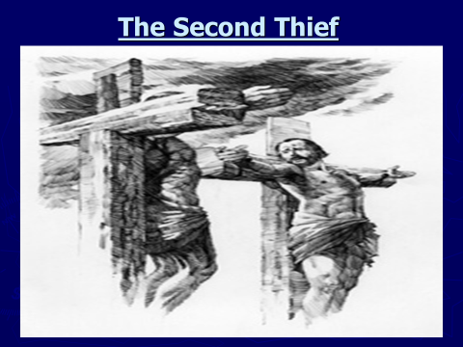
One of the criminals hanging there hurled insults at him: “Aren’t you the Messiah? Save yourself and us!”
The other one, however, questioned the other criminal saying, “Don’t you fear God? You received the same sentence he did. Ours, however, is only right because we are getting what we deserve; but he has done no wrong.”
And he said to Jesus, “Jesus, Remember me, when you come into Your Kingdom!”
Jesus said to him, “I promise you that today you will be in Paradise with me.”

Pray together: (say aloud)
Jesus, You love us.
Help us to remember that how we behave and do things in our lives affect others.
Teach us to listen and follow You, like You have taught us to do.
Thank You, Jesus, for saving us all.

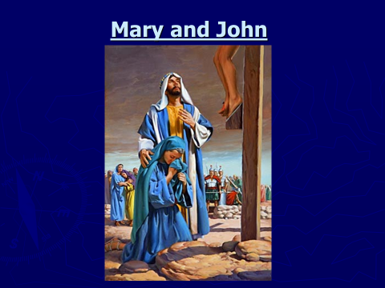
Mary and John
Standing close to Jesus’ cross were his mother, Mary, his mother’s sister, Mary the wife of Clopas, and Mary Magdalene. Jesus saw his mother and the disciple he loved standing there, so he said to his mother, “He is your son.” Then he said to the disciple, “She is your mother.”
From that time the disciple took her to live in his home.

Pray together: (say aloud)
Jesus, we know You love us. You gave us Your mother Mary as our own Mother.
Help us to remember to ask Mary for her nurturing love, compassion and understanding when we are in need or for the needs of others.
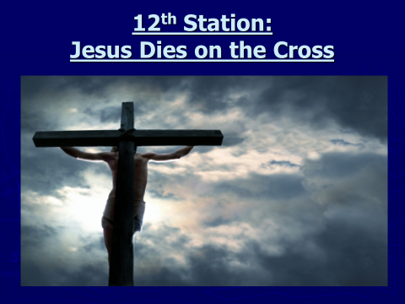
12 Station: Jesus dies on the Cross
When they come to Jesus, they saw that he was already dead, so they did not break his legs. One of the soldiers, however, plunged his spear into Jesus’ side, and at once blood and water poured out.
It is finished! No words can express the depth of Jesus’ death on the cross. No words can describe the depth of love offered by Jesus. We bend in silent adoration on our knees before the mystery of the crucifixion.
Pray together: (say aloud)
Jesus, You love us. Teach us Your way.
Give us wisdom and courage to love and value others as you did.
Thank You for loving us so much that You gave us the opportunity to live.

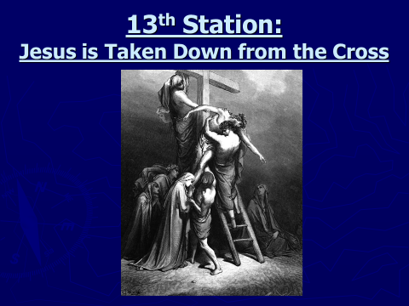
13th Station: Jesus is Taken Down from the Cross
“My Son! Mary holds on her lap the dead body of her Son, Jesus whom she has held as a child. He was her life, the centre and meaning of her life. She enwraps him with her tenderness and love.

Pray together: (say aloud)
Jesus, we know You love us.
Help us to care for others like your Mother cared for you.
Pray for all those who have faced a loss of a loved one in their life.
Thank you for all that You have done for us.
Because of Your sacrifice, we know that You will always be with us.
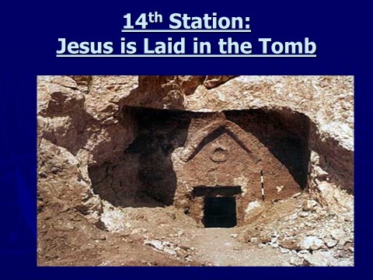
14th Station: Jesus is Laid in the Tomb

When it was evening, a rich man from Arimathea arrived; his name was Joseph, and he also was a disciple of Jesus.
He went to Pilate and asked for the body of Jesus.
Pilate gave orders for the body to be given to Joseph.
So Joseph took it, wrapped it in a new linen sheet, and placed it in his own tomb, which he had just recently dug out of solid rock. Then he rolled a large stone across the entrance to the tomb and left for the evening.

Pray together: (say aloud)
Jesus, You love us.
It is hard to say “Goodbye”, especially when we care so much.
Jesus loves us a lot. He knows what is in our heart. Please be with us always.
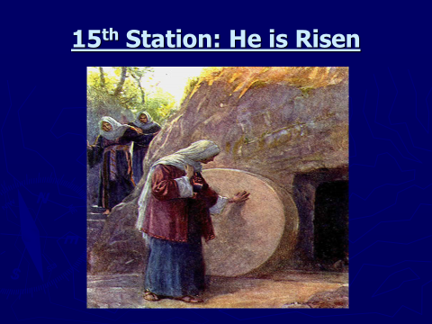
15th Station: The Resurrection: He is Risen (3 pictures)

Very early on Sunday morning the women went to the tomb, carrying the spices they had prepared. They found the stone rolled away from the entrance to the tomb, so they went in; but they did not find the body of Jesus.

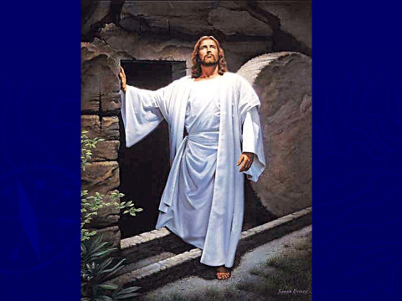
Jesus has risen from the dead.
We celebrate the ultimate power and glory of God in the Resurrection of Jesus.
The “Alleluia” is the answer.

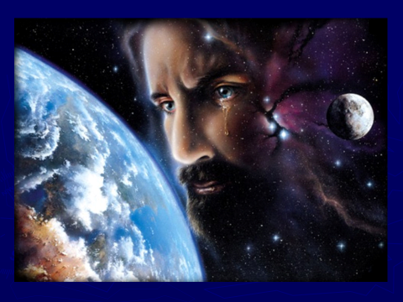
The message of life bursts out beyond time and space; the fullness of life promised by Jesus is the ultimate truth and reality.

Pray together: (say aloud)
Jesus, You love us. You have returned to be with us. Be our promise and our hope. Thank You Jesus for our lives, and for all the wonderful things that we can see, hear, taste, touch, and smell. Thank You for everything.

Closing Prayer:
God our Father,
Your only Son gave up His life for us.
Help us to better understand by looking at the Way of Cross often.
Thank You for everything that You have done for us and continue to do.
Help us to grow in love and know that You will never abandon us.
This we ask through Christ our Lord,
Amen.

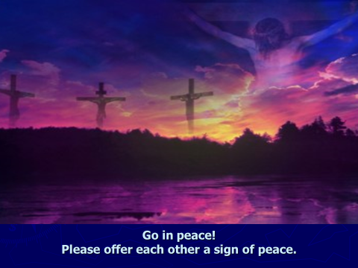
The Celebration is ended.

Go in peace!

Please offer each other a sign of peace.
(a elbow or a nod)

“Peace be with you”

